**ISE ASSIGNMENT #3**

**Q1.**

In unit testing, we focus on testing the functionality of object classes with several attributes and methods therefore it is not desirable in all circumstances. The reason is that the classes are encapsulated so many small testable pieces cannot be tested using the same operation. So it requires a change of approach. Along with that inheritance makes it difficult to design object class tests as the access modifiers don’t allow the access of data everywhere.

**Q2.**

Validation test includes unit, system, integration, and user acceptance testing. Therefore both type of users should be performing, in system and integration testing, software developers get to check the emergent behavior of the system. Whereas in user acceptance testing software users provide the input and advice on system testing and they decide whether it is ready to be deployed in a customer environment. Along with that both of them would be developing test cases for testing which would further minimize the chance of errors.

**Q3.Bubble sort algorithm and path testing**

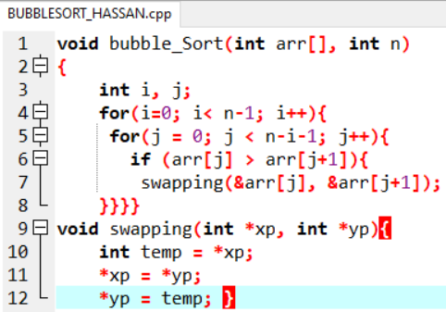



**Q4. Equivalence partition testing test cases**

